Project Design Phase
Solution Architecture

Date | 15 February 2025
Team ID
Project Name | AI Blog Nest API
Maximum Marks | 4 Marks

Solution Architecture:
Solution architecture bridges the gap between business problems and technology solutions. For AI Blog Nest API its goals are to:
- Find the best tech solution to the problem of slow, fragmented AI-assisted blog creation.
- Describe the structure, characteristics and behaviour of the API to project stakeholders.
- Define features, development phases and solution requirements.
- Provide specifications according to which the solution is defined, managed and delivered.
Solution Architecture Diagram:
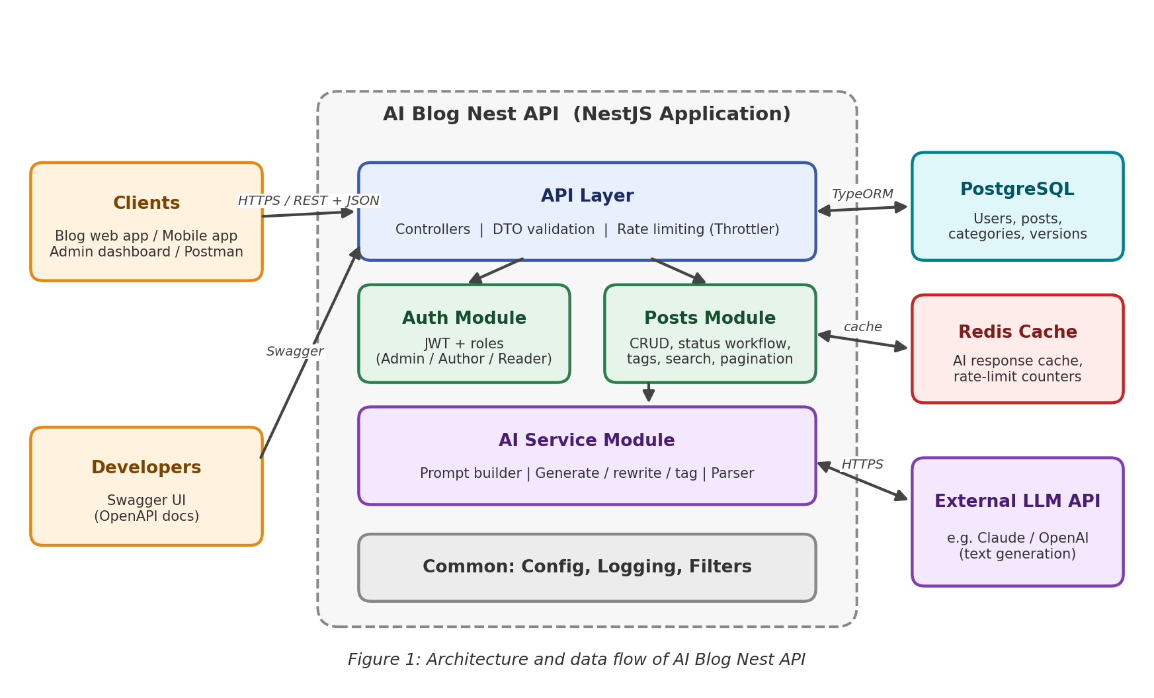
Components:
Component | Responsibility
Clients | Web or mobile blog front-ends, admin dashboards and API tools such as Postman call the API over HTTPS using JSON.
API Layer | NestJS controllers receive requests, validate input with DTOs (class-validator) and apply rate limiting.
Auth Module | Registration, login, JWT access and refresh tokens, and role guards for Admin, Author and Reader.
Posts Module | Blog CRUD, Draft / Published / Archived workflow, categories, tags, search, pagination and version history.
AI Service Module | Builds prompts, calls the external LLM, parses the response, and exposes generate, rewrite, summarise and tag functions.
PostgreSQL | Primary database for users, posts, categories, tags and post versions, accessed through TypeORM.
Redis Cache | Caches repeated AI responses and keeps rate-limit counters.
External LLM API | Third-party language model (for example Claude or OpenAI) that produces the generated text.
Swagger / OpenAPI | Auto-generated interactive documentation for developers.
Data Flow (example: generate a blog draft):
- The client sends POST /ai/generate with a topic, keywords and tone, plus a JWT.
- The API layer validates the request body, and the Auth module verifies the token and the user’s role.
- The AI Service checks Redis for a cached result for the same request.
- On a cache miss, it builds a prompt and calls the external LLM API.
- The response is parsed into title, body, summary and tags, and stored in Redis.
- The Posts module saves the result as a Draft in PostgreSQL and records a version.
- The API returns the draft as JSON; the author reviews, edits and publishes it.
Technology Stack:
- Backend framework: NestJS (Node.js, TypeScript)
- Database: PostgreSQL with TypeORM
- Security: JWT, bcrypt password hashing, role guards, Throttler rate limiting
- AI: External LLM API (Claude / OpenAI) via a provider-agnostic service
- Cache: Redis
- Docs, testing and deployment: Swagger (OpenAPI), Jest for unit and e2e tests, Docker
Reference: https://docs.nestjs.com/

